Requirements

UI Requirements:

1.Login Screen:
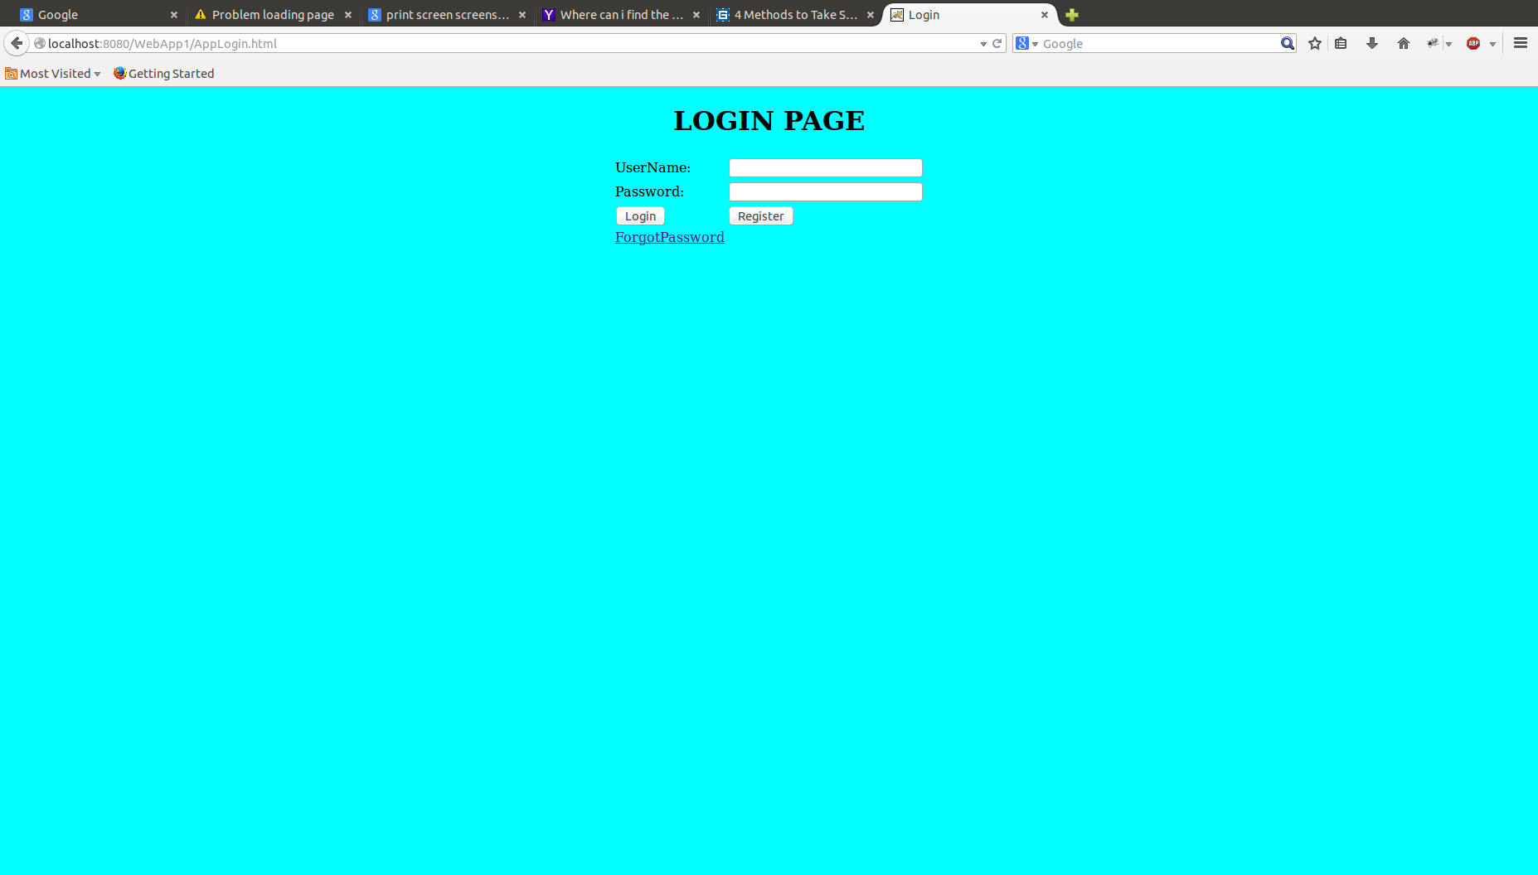

- User need to provide the valid credentials to enter into the application.

- On clicking register button it should navigate to register page.

2.Registration Screen:
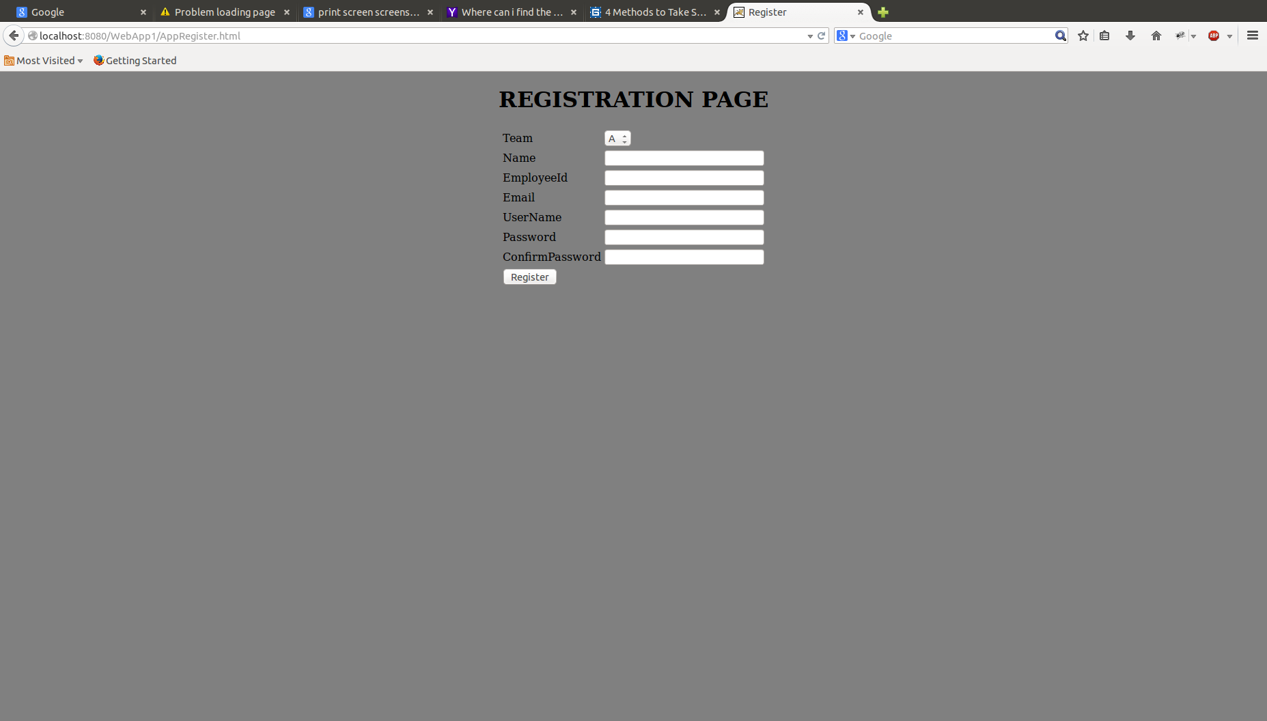

- Here the user need to provide the above details to register.

- When he clicks on register button it should navigate to login page.

3.Admin Page:

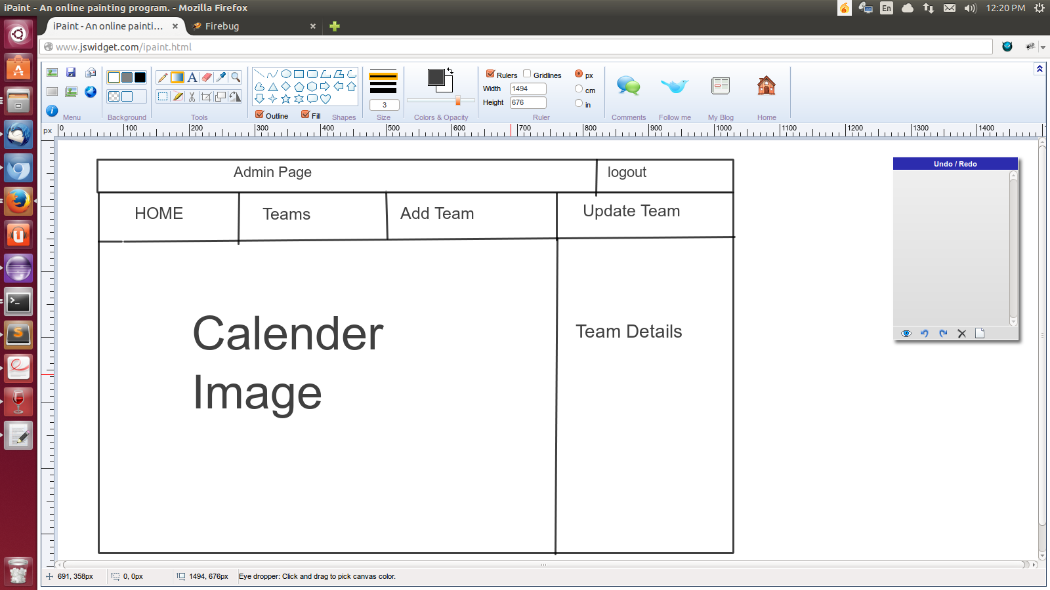

- When admin logged in successfully he should navigate to admin page.

- The admin can perform operations like add team and update the team.

4.User Page:

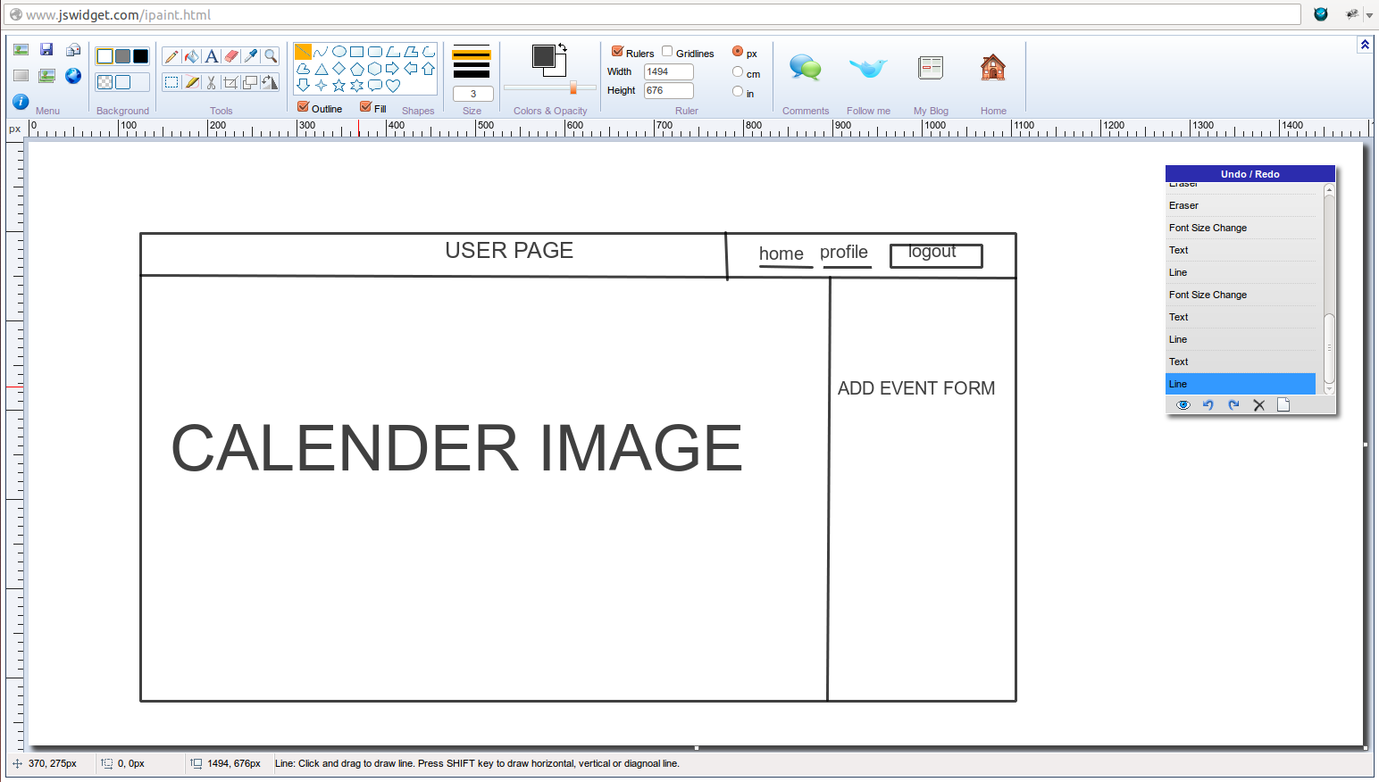

- When user logged in successfully he should navigate to user page.

- Here the user can view the events, add the new event and update.

- Here user can update his profile.

